academic_engagement

Kevin Gilds, MPA

June 13, 2016

# Academic Engagement

Academic Engagement questions gauge tangible behaviors that help students succeed in school. Questions that measure Academic Engagement include the following. Number Question 1. I talk with my teachers before or after school, or during lunch about my assignments. 2. I hand in my assignments on time 3. I finish my homework even if it is boring 4. If I can't understand my schoolwork at first, I keep trying until I do understand it.

The number of pre and post survey that could be matched is **272**.

1. The number of students achieving the academic engagment outcome at a high level is **212**
2. The number of students who did not achieve outcome at high level but increased their outcome score is **60**

The percent of students with a successful outcome is **83.46%**

The improvement in outcome scores is graphically represented below.

ae_2016 <- ae_all %>%  
 filter(Year_Id == "M3")

pre_ae_histq <- qplot(ae_2016$Pre, geom="histogram", main= "Pre Survey", bins=50, xlab="Outcome Scores" ) + geom_vline(xintercept = 4.5, col="red")   
  
  
post_ae_histq <-qplot(ae_2016$Post, geom="histogram", main= "Post Survey", bins=50, xlab="Outcome Scores", ylim=c(0,50)) + geom_vline(xintercept = 4.5, col="red")  
  
grid.arrange(pre_ae_histq, post_ae_histq, ncol=2)

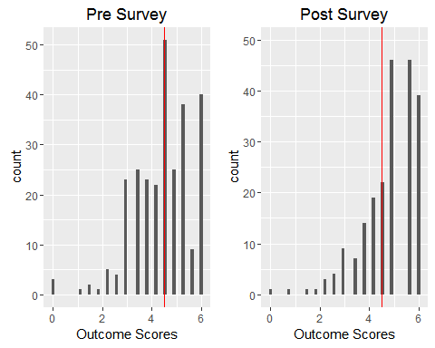

ae_bar_pre <-qplot(ae_2016$Pre >=4.5, geom="bar", ylim=c(0, 200), main="Pre survey Results", xlab="Achievment at High Level")  
  
ae_bar_post <-qplot(ae_2016$Post >=4.45, geom ="bar", main="Post Survey Results", xlab="Achievment at High Level")  
  
grid.arrange(ae_bar_pre, ae_bar_post, ncol=2)

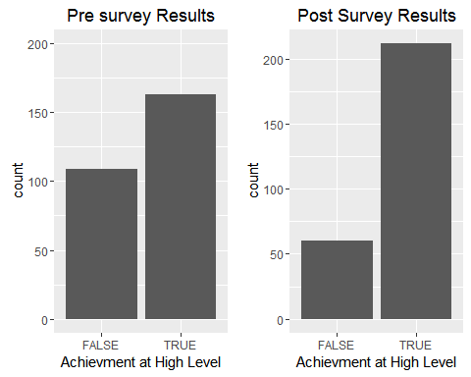

ae_change <- ae_2016 %>%  
 filter(Pre !=6.0 & Post !=6.0)

The percent of students who went from low achievement to hig achievement is **27.94%** The number of students who had the opportunity to improve their academic engagement outcome score is **207**, and the mean increase in outcome score is **0.5543478**

The increase in the academic engagement outcome scores is represented graphically below. Marks to the right of the veticial red line represents an increase in the outcome score. Marks above the horizintal line represents scores above the high and low achievement.

ae_change <- ae_2016 %>%  
 filter(Pre !=6.0 & Post !=6.0)  
  
  
mean(ae_change$ae.diff)

## [1] 0.5543478

ae_change_p <- ggplot(ae_change,(aes(x=ae.diff, y=Pre)))  
ae_change_p + geom_count() + geom_hline(yintercept = 4.5) + geom_vline(xintercept = 0, col="red") + labs(x="Pre and Post Difference", y="Pre Outcome Score", title="Academic Engagement Survey Results")

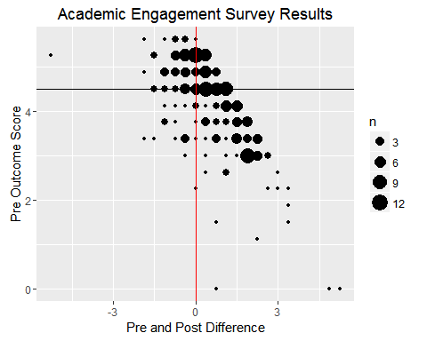

A wilcox.test was administered on the healthy relationship outcome data and the results show that the

pander(wilcox.test(ae_2016$Pre, ae_2016$Post))

Wilcoxon rank sum test with continuity correction: ae_2016$Pre and ae_2016$Post

|  |  |  |
| --- | --- | --- |
| Test statistic | P value | Alternative hypothesis |
| 27134 | 5.952e-08 * * * | two.sided |

cohen.d(ae_2016$Pre, ae_2016$Post, paired=TRUE)

##   
## Cohen's d  
##   
## d estimate: -0.3644765 (small)  
## 95 percent confidence interval:  
## inf sup   
## -0.5346291 -0.1943239

## Cross Validation of Academic Engagment

Survey results from teachers and parents also provide evidence that the Get REAL! program helps students learn tangible tools to help them succeed in school. Below are tables that provide a breakdown of questions on the post survey from the parent and teacher surveys. The pattern again shows improvement in moderate agreement with the question being both with the parent survey and teacher survey.

Parent Survey Question:

pre_parent <- dbReadTable(getReal_2016db, "pre_parent")  
  
post_parent <- dbReadTable(getReal_2016db, "post_parent")

# Pre Survey

colnames(pre_parent)[15] <- "hmwrk_super"  
  
pre_parent_tbl <- pre_parent %>%  
 select(15)  
  
names(pre_parent_tbl)

## [1] "hmwrk_super"

pre_parent_tbl$hmwrk_super <- factor(pre_parent_tbl$hmwrk_super, levels=c("Strongly Disagree", "Disagree", "Slightly Disagree", "Neither Agree/Disagree", "Slightly Agree", "Agree", "Strongly Agree"),ordered = TRUE)

pre_parent_tbl <- likert(pre_parent_tbl)  
  
summary(pre_parent_tbl)

## Item low neutral high mean sd  
## 1 hmwrk_super 1.72043 8.602151 89.67742 6.352688 1.102661

plot(pre_parent_tbl, type="heat") +ggtitle("Question: She works on her homework at home without supervision.")

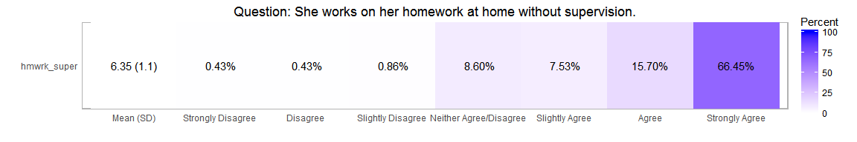

colnames(post_parent)[15] <- "hmwrk_super"  
  
post_parent_tbl <- post_parent %>%  
 select(15)  
  
post_parent_tbl$hmwrk_super <- factor(post_parent_tbl$hmwrk_super, levels=c("Strongly Disagree", "Disagree", "Slightly Disagree", "Neither Agree/Disagree", "Slightly Agree", "Agree", "Strongly Agree"),ordered = TRUE)

post_parent_tbl <- likert(post_parent_tbl)  
  
summary(post_parent_tbl)

## Item low neutral high mean sd  
## 1 hmwrk_super 1.639344 0 98.36066 6.565574 0.7959538

plot(post_parent_tbl, type="heat") + ggtitle("Question:She works on her homework at home without supervision.")

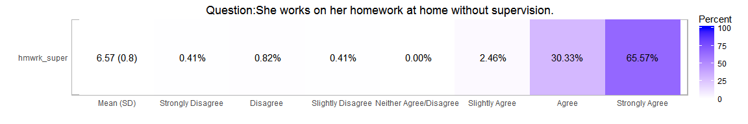

# Teacher Survey

Teacher Survey Question: She completes the homework given to her.

post_teacher <- dbReadTable(getReal_2016db, "post_teacher")  
  
colnames(post_teacher)[15] <- "hmwrk_super"  
  
  
  
post_teacher_tbl <- post_teacher %>%  
 select(15)  
  
  
  
post_teacher_tbl$hmwrk_super <- factor(post_teacher_tbl$hmwrk_super, levels=c("Strongly Disagree", "Disagree", "Slightly Disagree", "Neither Agree/Disagree", "Slightly Agree", "Agree", "Strongly Agree"),ordered = TRUE)

post_teacher_tbl <- likert(post_teacher_tbl)  
  
summary(post_teacher_tbl)

## Item low neutral high mean sd  
## 1 hmwrk_super 0.8287293 0 99.17127 6.51105 0.6498579

plot(post_teacher_tbl, type="heat") + ggtitle("Question: She completes the homework given to her") + theme_dark ()

